Name : Aria Widiyo Noviyanto

Class : X

NIM : L200183043

Exercise 1

1. Make Logic Gates on picture

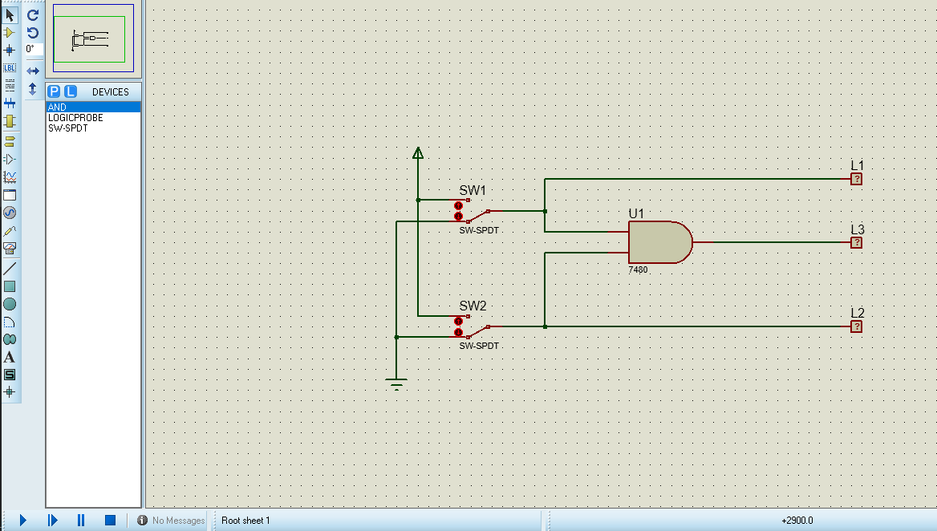

1. Truth Table.

|  |  |  |  |  |
| --- | --- | --- | --- | --- |
| S W 1 | SW 2 | L1 | L2 | L3 |
| 0 | 0 | 0 | 0 | 0 |
| 1 | 0 | 1 | 0 | 0 |
| 0 | 1 | 0 | 0 | 1 |
| 1 | 1 | 1 | 1 | 1 |

1. Diagram Time.

|  |  |  |  |  |
| --- | --- | --- | --- | --- |
| L1 |  |  |  |  |
|  |  |
|  |  |  |  |
|  |  |
| L2 |  |  |  |  |
|  |
|  |  |  |  |
|  |  |  |
| L3 |  |  |  |  |
|  |  |
|  |  |  |  |
|  |  |

1. Make Logic Gates on this picture

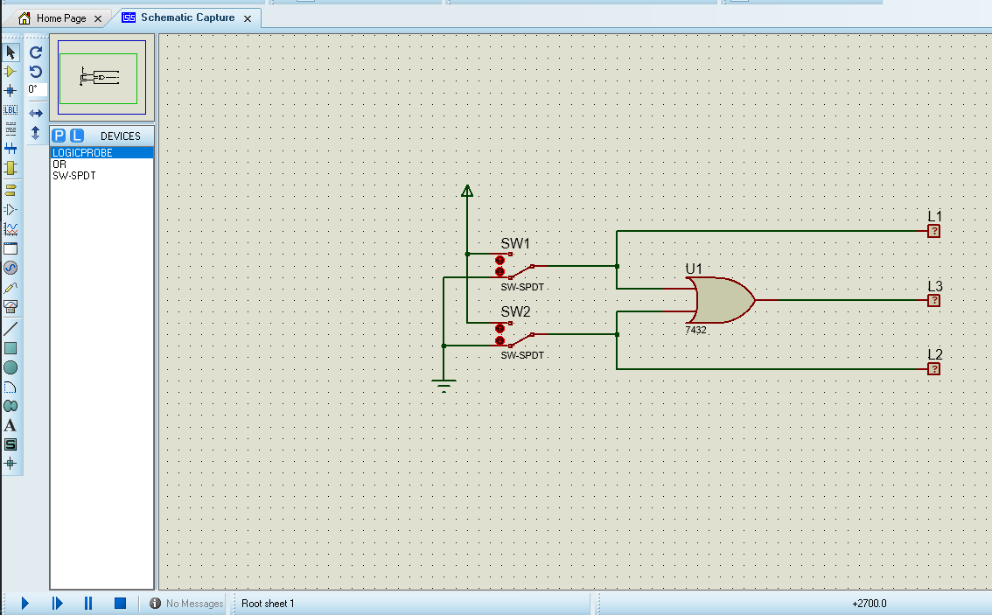

1. Truth Table.

|  |  |  |  |  |
| --- | --- | --- | --- | --- |
| S W 1 | SW 2 | L1 | L2 | L3 |
| 0 | 0 | 0 | 0 | 0 |
| 1 | 0 | 1 | 0 | 0 |
| 0 | 1 | 0 | 1 | 1 |
| 1 | 1 | 1 | 1 | 1 |

1. Diagram Time.

|  |  |  |  |  |
| --- | --- | --- | --- | --- |
| L1 |  |  |  |  |
|  |  |
|  |  |  |  |
|  |  |
| L2 |  |  |  |  |
|  |  |
|  |  |  |  |
|  |  |
| L3 |  |  |  |  |
|  |  |
|  |  |  |  |
|  |  |

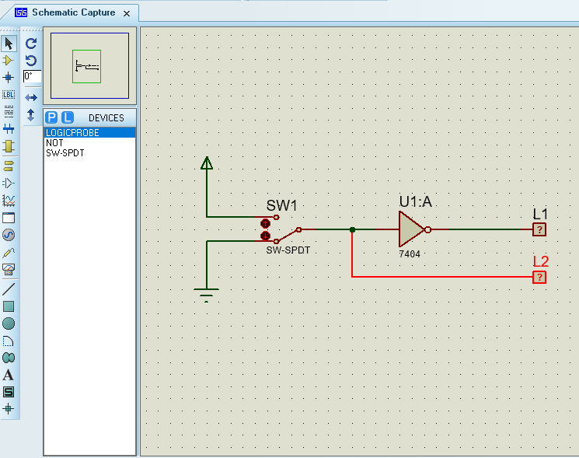

1. Truth Table.

|  |  |  |
| --- | --- | --- |
| S W 1 | L2 | L1 |
| 0 | 0 | 1 |
| 1 | 1 | 0 |

1. Diagram Time.

|  |  |  |
| --- | --- | --- |
| L1 |  |  |
|  |
|  |  |
|  |
| L2 |  |  |
|  |
|  |  |
|  |

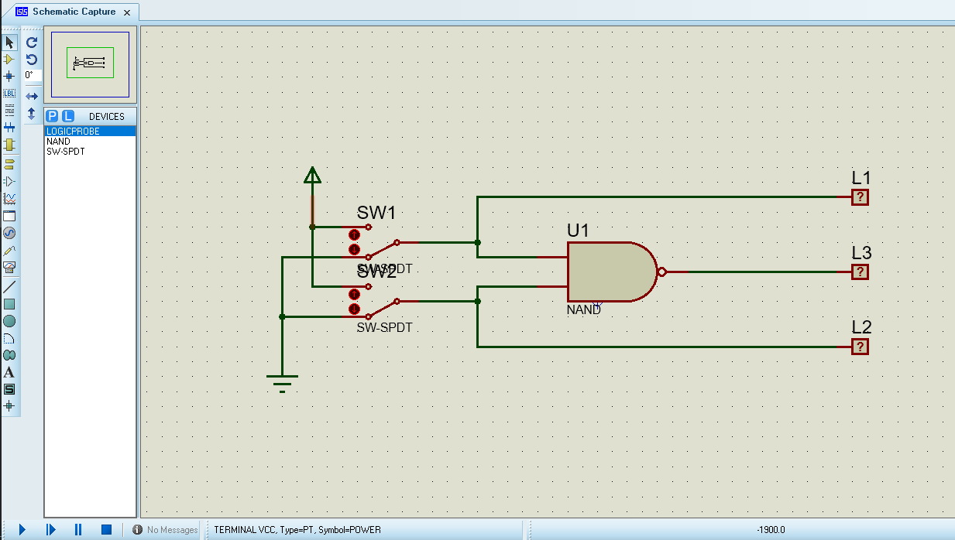

1. Truth Table.

|  |  |  |  |  |
| --- | --- | --- | --- | --- |
| S W 1 | SW 2 | L1 | L2 | L3 |
| 0 | 0 | 0 | 0 | 1 |
| 1 | 0 | 1 | 0 | 1 |
| 0 | 1 | 0 | 1 | 1 |
| 1 | 1 | 1 | 1 | 1 |

1. Diagram Time.

|  |  |  |  |  |
| --- | --- | --- | --- | --- |
| L1 |  |  |  |  |
|  |  |
|  |  |  |  |
|  |  |
| L2 |  |  |  |  |
|  |  |
|  |  |  |  |
|  |  |
| L3 |  |  |  |  |
|  |  |  |  |
|  |  |  |  |

1. 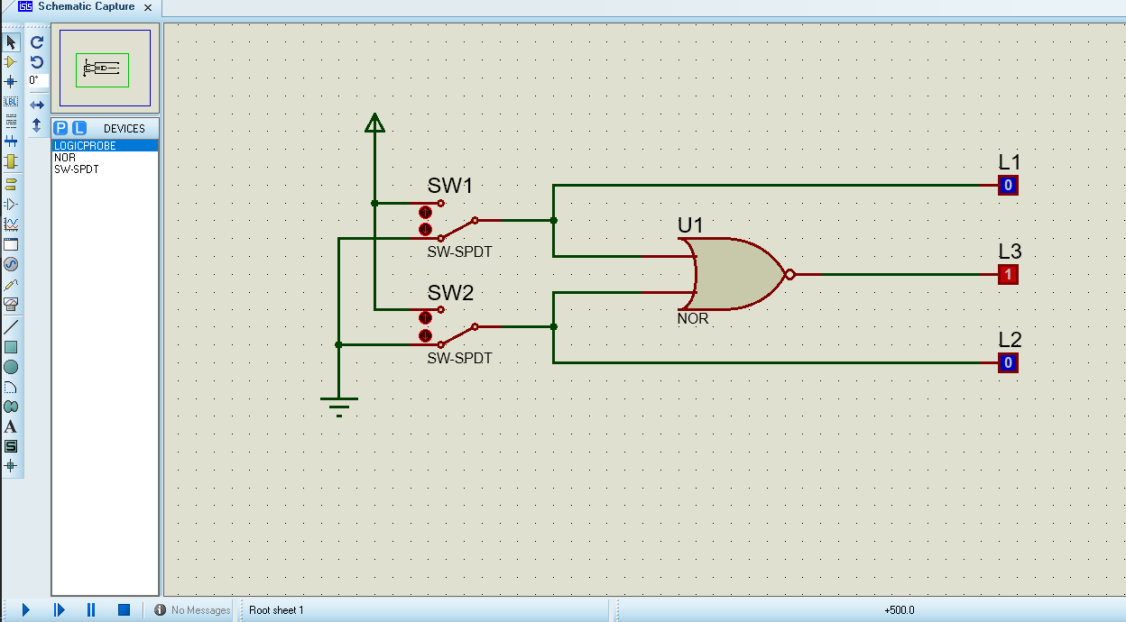Make Logic Gates on this Picture.
2. Truth Table.

|  |  |  |  |  |
| --- | --- | --- | --- | --- |
| S W 1 | SW 2 | L1 | L2 | L3 |
| 0 | 0 | 0 | 0 | 1 |
| 1 | 0 | 1 | 0 | 0 |
| 0 | 1 | 0 | 1 | 1 |
| 1 | 1 | 1 | 1 | 0 |

1. Diagram Time.

|  |  |  |  |  |
| --- | --- | --- | --- | --- |
| L1 |  |  |  |  |
|  |  |
|  |  |  |  |
|  |  |
| L2 |  |  |  |  |
|  |  |
|  |  |  |  |
|  |  |
| L3 |  |  |  |  |
|  |  |
|  |  |  |  |
|  |  |

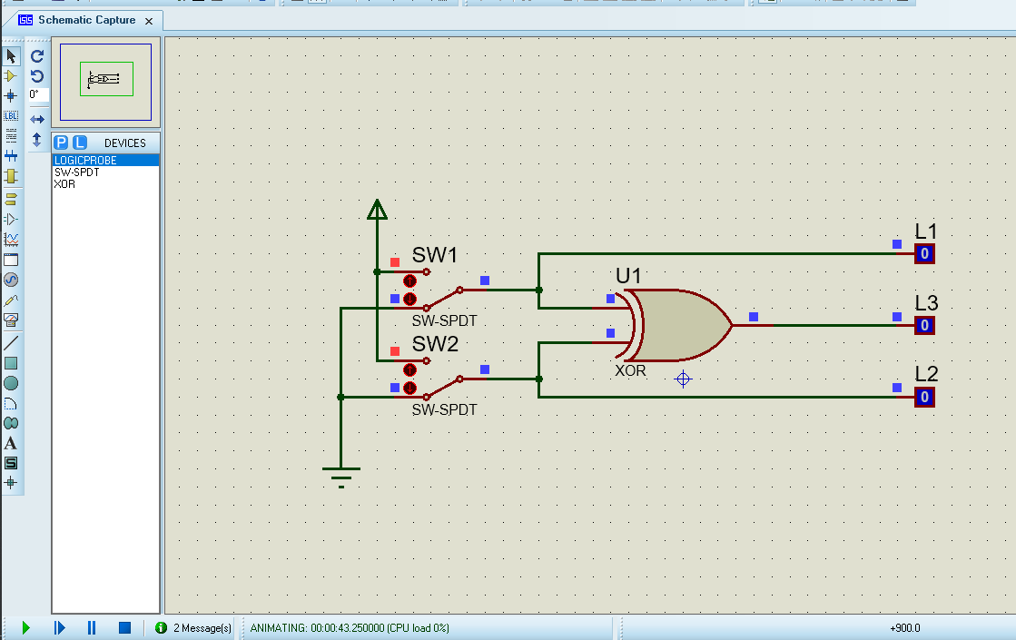

1. Truth Table.

|  |  |  |  |  |
| --- | --- | --- | --- | --- |
| S W 1 | SW 2 | L1 | L2 | L3 |
| 0 | 0 | 0 | 0 | 0 |
| 1 | 0 | 1 | 0 | 1 |
| 0 | 1 | 0 | 1 | 1 |
| 1 | 1 | 1 | 1 | 0 |

1. Diagram Time.

|  |  |  |  |  |
| --- | --- | --- | --- | --- |
| L1 |  |  |  |  |
|  |  |
|  |  |  |  |
|  |  |
| L2 |  |  |  |  |
|  |  |
|  |  |  |  |
|  |  |
| L3 |  |  |  |  |
|  |  |
|  |  |  |  |
|  |  |

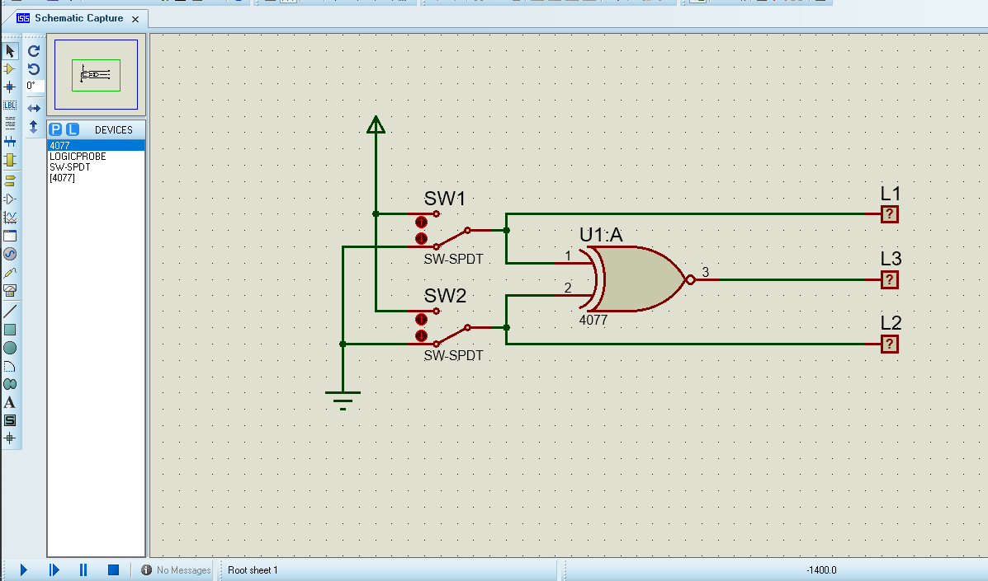

1. Truth Table.

|  |  |  |  |  |
| --- | --- | --- | --- | --- |
| S W 1 | SW 2 | L1 | L2 | L3 |
| 0 | 0 | 0 | 0 | 1 |
| 1 | 0 | 1 | 0 | 0 |
| 0 | 1 | 0 | 1 | 0 |
| 1 | 1 | 1 | 1 | 1 |

1. Diagram Time.

|  |  |  |  |  |
| --- | --- | --- | --- | --- |
| L1 |  |  |  |  |
|  |  |
|  |  |  |  |
|  |  |
| L2 |  |  |  |  |
|  |  |
|  |  |  |  |
|  |  |
| L3 |  |  |  |  |
|  |  |  |
|  |  |  |  |
|  |